Visualizing and Predicting Heart Diseases with an Interactive Dash Board

Team ID: PNT2022TMID10044

Faculty Mentor: Team Leader : Sakthivel M

T K P Rajagopal Team Member : Sadhana M

Team Member :Sirisha G

Team Member : Sneha Bharathi V

Exploration of Data :

Exploration of Data relationships among the values is presented along with plotting of Average Age for different Chest Pain Types. For visualizing it, we will require the following data:

* Sex
* Age
* Chest Pain Type

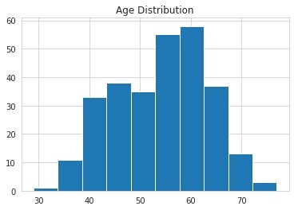

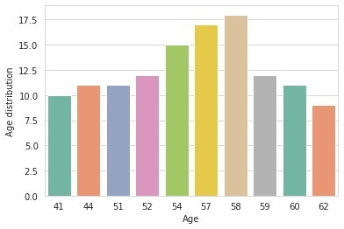

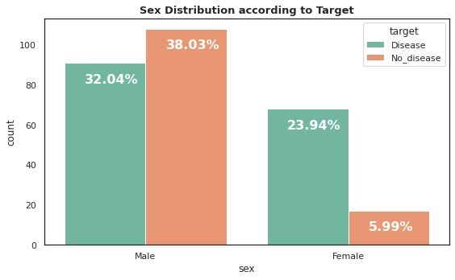

From the bar graph, we can observe that among disease patients, male are higher than female.

Chest pain distribution according to target variable :

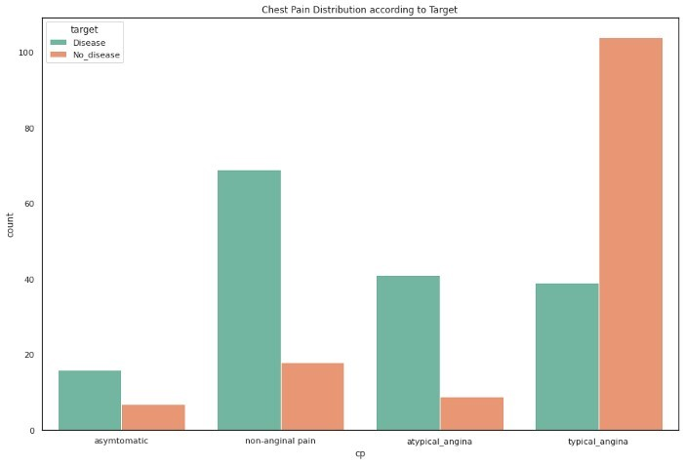

Chest pain (cp) or angina is a type of discomfort caused when heart muscle doesn’t receive enough oxygen rich blood, which triggered discomfort in arms, shoulders, neck, etc.

However, looking at the bar graph above, its raised a question of higher number of healthy subject having typical_angina. Or in other word, most of the healthy subject having chest pain, which is also discussed here.

Chest pain can be subjective due to stress, physical activities and many more and varies between gender. Women and elderly patients usually have atypical symptoms with a history of disease. This article provide analysis comparing typical anginal vs nontypical angina patients in a clinical trial.